Module 1 Activities 1.1-1.4 (Submission link)
Activity 1-1: Determining the Corporate Need for IT Security Professionals
Objective: Examine current job postings for IT security professionals and identify the key skills companies seek.
Step 1 —Open Indeed. I used it for the search.
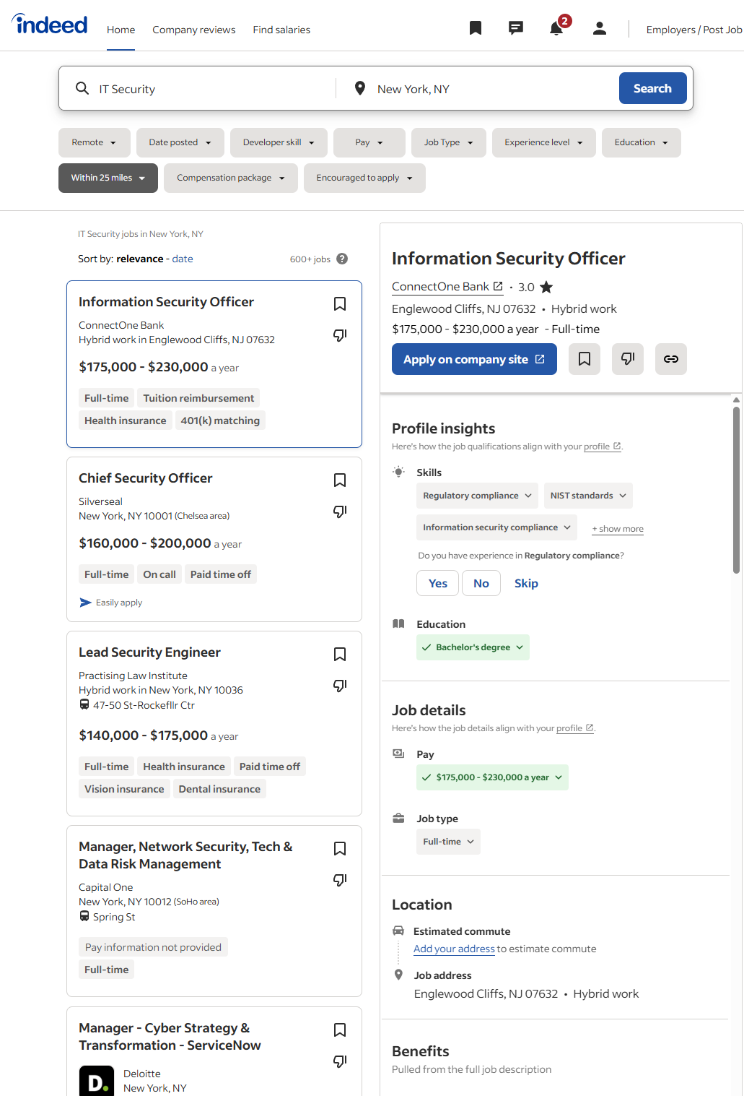
Step 2 — After Opened Indeed I saw 600+ IT Security jobs in New York, NY at the time I checked.

Step 3 — Selected Job Postings
 | Job Title & Company | Salary Range / Type | Key Technical Skills Requested | Key Non-Technical Skills / Notes
1 | Information Security Officer – ConnectOne Bank (Englewood Cliffs, NJ) | $175 k – $230 k / Full-time | Regulatory compliance NIST standards Information security policies  Risk management | Leadership  Policy development Bachelor’s degree required  Strong communication
2 | Lead Security Engineer – Practising Law Institute (NYC) | $140 k – $175 k / Full-time | Network security  Threat analysis Vulnerability management  Secure architecture | Attention to detail  Team coordination Problem solving
3 | Manager – Cyber Strategy & Transformation (ServiceNow) – Deloitte (NYC) | $144 k – $265 k / Full-time | Cyber strategy  Incident response  Cloud security  Governance frameworks | Client communication Leadership  Project management
4 | Manager, Network Security, Tech & Data Risk Management – Capital One (NYC) | Not listed / Full-time | Data risk management Network security Compliance controls Cloud environments | Collaboration  Policy reporting Analytical thinking
5 | Chief Security Officer (CSO) – Silverseal (New York, NY) | $160 K – $200 K / Full-time | Enterprise risk management  Incident response  Policy development  Crisis management | Executive leadership Strategic planning

Step 4 — I finished search and I exited it, I have some common finding from job search
Top Technical Skills
- Network & cloud security (AWS, Azure)
- Vulnerability assessment / risk management
- Regulatory & compliance frameworks (NIST, ISO, HIPAA)
- Incident response / security operations
- Secure architecture and data protection
Top Non-Technical Skills
- Leadership and team coordination
- Strong communication (oral and written)
- Analytical and problem-solving ability
- Collaboration with executives and clients
- Bachelor’s degree and/or industry certifications (CISSP, CISM, CEH, PenTest+)

Conclusion
The Indeed.com search for IT Security jobs in the New York area returned more than 600 openings, indicating a very strong demand for security professionals. Employers consistently look for expertise in network security, compliance, and risk management, paired with soft skills such as leadership and communication. The wide range of roles from security engineer to chief security officer demonstrates the career diversity and high earning potential in the IT security field.

Activity 1-2 Examining the Top 25 Most Dangerous Software Flaws
Objective: Examine the SANS list of the most common network exploits and understand several major vulnerabilities that attackers often use.

Step 1 — Start your web browser
I opened Google Chrome and entered https://www.sans.org in the address bar.
The home page loaded showing the text, World-Class, Expert-Led Cybersecurity Training and navigation options such as Training, Learning Paths, and Community Resources.
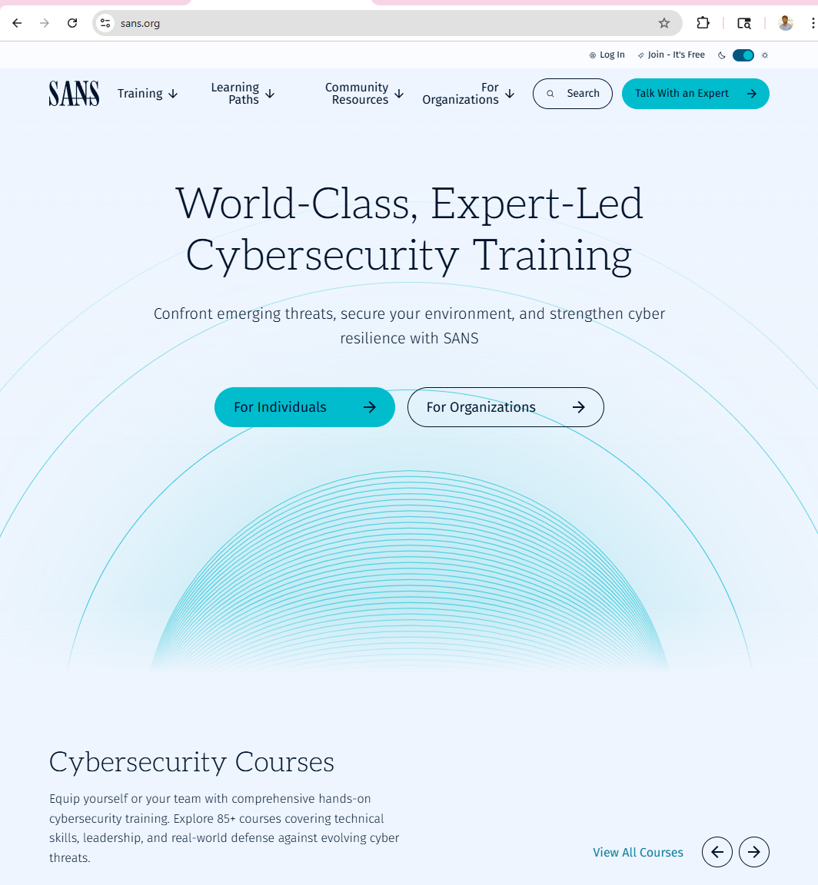

Step 2 — Under Resources, click the Top 25 Programming Errors link
From the SANS home page, I hovered over Community Resources in the top menu and selected. Top 25 Programming Errors.
This opened the page titled Dangerous Software Errors. The page displayed details about what is included in the Top 25 list ranking data, CWE links, remediation cost, detection methods, attack frequency, and prevention techniques.
Links were also provided to:
- The New 25 Most Dangerous Programming Errors
- The Scoring System
- The Risk Management System
- This step connects users to SANS Institute’s collaboration with MITRE CWE, which identifies the 25 most common and dangerous software flaws exploited by attackers

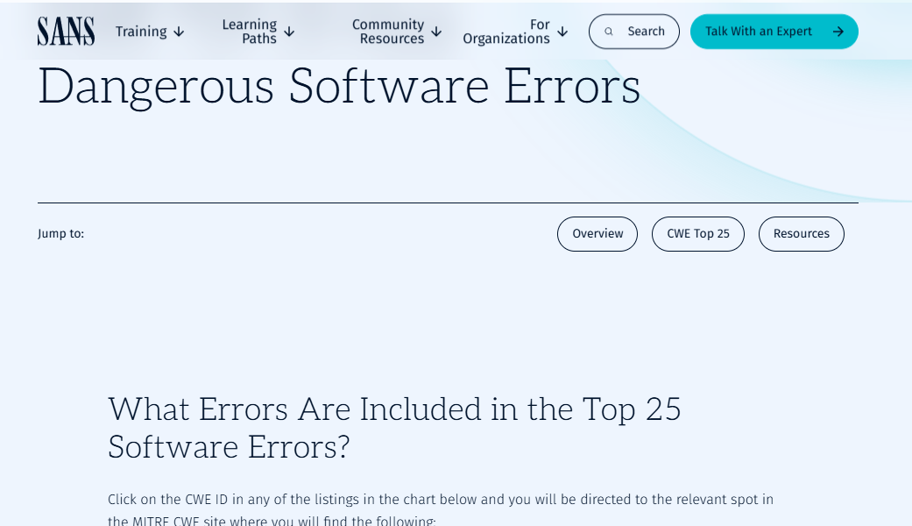

Step 3 - Read the contents of the Top 25 list
I scrolled through the CWE Top 25 Most Dangerous Software Errors page.
It lists the 25 most common and high-impact programming flaws that attackers frequently exploit. Each entry links to the MITRE CWE site, where users can read full definitions, examples, attack patterns, and mitigations.
The list also includes scoring details that show how the SANS/MITRE framework ranks these weaknesses based on:
- Frequency in reported vulnerabilities
- Severity of potential impact
- Ease of detection and exploitability

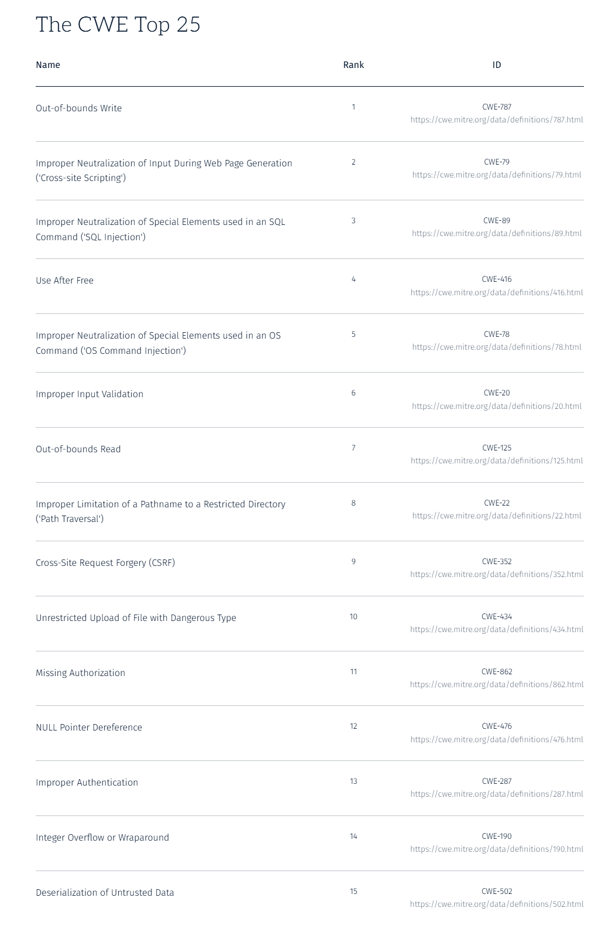
This list helps developers and security professionals understand which software flaws are the most critical to fix or test for.

Step 4 — Investigate the first few flaws by clicking the CWE links
I clicked the first few CWE IDs and reviewed their descriptions. Below is a short table summarizing the key details for the top five flaws:
Rank / CWE ID | Name of Flaw | Description / Cause | Applicable Platform(s) | Consequences if Exploited
 |  | Program writes data outside the memory buffer due to bad indexing or pointer misuse. | System software, firmware, embedded C/C++ apps | Memory corruption, crash, privilege escalation, remote code execution
  1 / CWE-787
  Out-of-Bounds Write
2 / CWE-79 | Cross-Site Scripting (XSS) | User input is not sanitized before displayed on a web page. | Web applications (HTML/JavaScript) | Session hijacking, credential theft, phishing attacks
3 / CWE-89 |  |  | Database-driven apps (web, mobile, desktop) | Data theft, unauthorized modification, database control
  SQL Injection
  Input is directly inserted into SQL queries without validation or escaping.
4 / CWE-416 | Use After Free | Program accesses memory after it has been freed. | Low-level languages (C/C++) | Memory corruption, system crash, arbitrary code execution
5 / CWE-78 | OS Command Injection | External input is used in a system command without validation. | Server apps and scripts | Remote command execution, complete system compromise
By studying these CWEs, I learned how improper input handling and unsafe memory practices can cause serious vulnerabilities. Each CWE entry includes prevention methods such as input validation, safe APIs, and memory bounds checking.
Step 5 — Exit your web browser
After reviewing several CWEs and reading their explanations, I closed the browser.
This completed my examination of the SANS Top 25 Most Dangerous Software Errors list.

Activity 1-4 Examining Federal and International Computer Crime Laws
Introduction
As cybersecurity professionals, ethical hackers and security testers must understand the legal framework governing their work. This summary examines two critical pieces of legislation: U.S. Code Title 18, Section 1030 (the Computer Fraud and Abuse Act) and the Convention on Cybercrime, commonly known as the Budapest Convention. Both of these legal instruments establish the boundaries between lawful security testing and criminal conduct.

U.S. Code, Title 18, Section 1030: Computer Fraud and Abuse Act (CFAA)

Overview
The Computer Fraud and Abuse Act, codified at 18 U.S.C. § 1030, is the primary federal statute addressing computer crimes. Enacted in 1984 as the Counterfeit Access Device and Computer Fraud and Abuse Act, it has been amended multiple times to address evolving cyber threats. This law criminalizes unauthorized access to computers and related malicious activities.

Key Provisions
The CFAA prohibits several categories of conduct. Understanding these provisions is essential for ethical hackers to ensure their authorized security testing activities remain legal:
- Unauthorized Access to Classified Information (18 U.S.C. § 1030(a)(1)): Prohibits knowingly accessing a computer without authorization or exceeding authorized access to obtain information protected for national defense or foreign relations. Intent to harm the United States or aid a foreign nation enhances the seriousness. Penalties include up to 10 years imprisonment (or 20 years for repeat offenders).
- Unauthorized Access to Protected Computers (18 U.S.C. § 1030(a)(2)): Makes it illegal to intentionally access a protected computer without authorization or to exceed authorized access, thereby obtaining information from government agencies, financial institutions, or computer fraud victims. Penalties range from 1 year (first offense) to 10 years (repeat offense) imprisonment.
- Accessing Government Computers (18 U.S.C. § 1030(a)(3)): Prohibits unauthorized access to computers used by federal government agencies. This is particularly important for ethical hackers to note—even scanning government networks without explicit written authorization can violate this provision.
- Fraud and Deception (18 U.S.C. § 1030(a)(4)): Criminalizes knowingly and intentionally accessing a protected computer without authorization (or exceeding authorized access) with intent to defraud and obtain anything of value. Penalties include up to 5 years for first offense, 10 years for subsequent offenses.
- Transmission of Harmful Code (18 U.S.C. § 1030(a)(5)): Prohibits knowingly causing the transmission of a program, information, code, or command that intentionally causes damage to a protected computer. This includes viruses, worms, and malware. Penalties depend on the damage caused but can reach 10 years imprisonment.
- Trafficking in Passwords (18 U.S.C. § 1030(a)(6)): Makes it illegal to knowingly and with intent to defraud traffic in passwords or similar information through which a computer may be accessed without authorization. Penalties include up to 1 year for first offense, 5 years for subsequent offenses.

Critical Terms for Ethical Hackers
Two key terms in the CFAA require clarification for security testers:
- Without Authorization: This means accessing a computer or network when you have no right to do so. Ethical hackers must have explicit written authorization from the system owner or authorized representative before conducting any penetration tests. Verbal approval is insufficient and provides no legal protection.
- Exceeding Authorized Access: Even if you have permission to access a system, exceeding the scope of that authorization is illegal. For example, if authorized to test web applications, accessing backend databases beyond your scope would violate the CFAA.

Impact on Ethical Hackers
- Ethical hackers must have written contracts that explicitly define the scope, targets, and authorized activities for each security test.
- The CFAA applies to security testers just as it does to malicious hackers—lack of criminal intent is not a sufficient defense if activities exceed authorization.
- Civil liability is possible even without criminal charges. Companies can sue for damages if testing causes harm beyond the authorized scope.
- Exceeding authorized access by even a small amount can result in federal prosecution. For example, accessing a system for legitimate security testing but then browsing employee files outside the scope would violate the law.
- Port scanning, which is a routine part of penetration testing, may be considered unauthorized access depending on jurisdiction and intent.

Convention on Cybercrime (Budapest Convention)

Overview
Officially known as the Council of Europe Convention on Cybercrime and commonly called the Budapest Convention, this treaty represents the first international binding instrument specifically addressing Internet and computer-related crimes. Signed in Budapest on November 23, 2001, it entered into force on July 1, 2004. The United States ratified the treaty in August 2006, and as of 2025, 81 states have ratified it, with an additional 2 having signed but not ratified.

Purpose and Objectives
- Harmonize national laws regarding cybercrime across signatory states
- Improve investigative techniques for detecting and prosecuting computer crimes
- Increase international cooperation among law enforcement agencies
- Establish procedures for obtaining electronic evidence across borders
- Protect society against cyber-based attacks and criminal behavior

Key Provisions
The Budapest Convention establishes four broad categories of cybercrime offenses that signatory countries must criminalize in their national legislation:
- Offences Against Confidentiality, Integrity, and Availability of Computer Data and Systems: Including illegal access to computer systems, illegal interference with data or systems, and misuse of devices for unauthorized access.
- Computer-Related Fraud and Forgery: Including fraud conducted through computer systems and forging digital documents.
- Content-Related Offences: Particularly child sexual abuse material (CSAM) and racist/xenophobic material transmitted through computer systems.
- Offences Related to Infringements of Copyright and Related Rights: Including unauthorized reproduction and distribution of copyrighted material via computer networks.

Procedural Provisions
Beyond defining offenses, the Budapest Convention also establishes procedural mechanisms for investigating cybercrime:
- Search and seizure of computer data and systems
- Interception of electronic communications (subject to human rights protections)
- 24/7 contact points for rapid international cooperation
- Mutual legal assistance frameworks for cross-border investigations
- Provisions for preservation of electronic evidence

Impact on Ethical Hackers and Security Testers
- The Budapest Convention harmonizes laws globally, meaning that illegal hacking in one signatory state is generally illegal in others. Security testers cannot exploit differences in national laws to conduct unauthorized testing.
- The Convention establishes international cooperation mechanisms that significantly increase the likelihood of prosecution for unauthorized hacking, even if the attacker operates from a different country.
- Because the Convention emphasizes electronic evidence preservation, unauthorized access attempts leave digital trails that can be recovered and used in prosecutions across multiple jurisdictions.
- The treaty requires all signatory countries to implement specific criminal provisions, so ethical hackers operating internationally must comply with all applicable national laws, not just their home country's laws.
- The Convention's emphasis on international cooperation means that law enforcement agencies worldwide actively share information about cybercrime, making it extremely risky to conduct unauthorized testing even in countries with weaker cybersecurity enforcement.

Comparative Analysis: CFAA vs. Budapest Convention
Aspect | CFAA (18 U.S.C. § 1030) | Budapest Convention
Scope | CFAA: Federal U.S. law only | Budapest Convention: International treaty covering 81+ countries
Primary Focus | CFAA: Unauthorized access and fraud | Budapest Convention: Multiple cybercrime categories including content-related offenses
Criminal Penalties | CFAA: Up to 20 years imprisonment | Budapest Convention: Each signatory country implements its own penalties
International Cooperation | CFAA: Limited to U.S. jurisdiction | Budapest Convention: Establishes mechanisms for cross-border cooperation
Evidence Standards | CFAA: U.S. standards apply | Budapest Convention: Harmonized standards for electronic evidence

Implications for Ethical Hackers and Security Testers
Written Authorization is Mandatory: Both the CFAA and Budapest Convention require explicit authorization. A written contract specifying the scope, duration, targets, and authorized methods of testing is essential. Verbal approval provides no legal protection.
Scope Creep is Illegal: Expanding testing beyond the authorized scope—even slightly—can result in federal prosecution in the U.S. and international prosecution under the Budapest Convention.
Intent Does Not Matter: Both laws focus on conduct, not intent. Even if you believe you are helping the organization, unauthorized access is illegal. Ethical hackers cannot assume that "for the company's benefit" justifies unauthorized testing.
Cross-Border Issues: The Budapest Convention makes it extremely dangerous to conduct security testing across international borders without clear understanding of each country's specific cybercrime laws. What is legal in one country may be illegal in another.
Evidence Preservation: Law enforcement agencies in Budapest Convention signatory countries can preserve electronic evidence of unauthorized access. This evidence can be shared internationally, making prosecution likely even if the attacker believed they could escape detection.
Need for Legal Review: Security testing companies should have contracts reviewed by attorneys familiar with both U.S. federal law (CFAA) and applicable international laws (Budapest Convention). The complexity of this legal landscape makes professional legal review essential.
Contractor Liability: Independent contractors are personally liable under both the CFAA and Budapest Convention provisions. Company employees conducting authorized testing under a corporate contract have some protection; independent contractors do not.

Best Practices for Compliance
- Obtain written authorization from a company representative with legal authority to authorize security testing
- Clearly define the scope of testing, including specific systems, networks, and applications to be tested
- Specify authorized testing methods and explicitly prohibit any techniques outside the scope
- Include clear start and end dates for the security testing engagement
- Require company approval before testing any systems beyond the initial scope
- Document all activities and maintain detailed logs of what was tested and when
- Implement a non-disclosure agreement (NDA) to protect sensitive information discovered during testing
- Include a clause specifying what should be done with vulnerabilities discovered
- Review all contracts with legal counsel before signing, especially for cross-border testing
- Verify that the authorizing company representative has legal authority to authorize testing
- Understand that the CFAA applies to security testers just as it applies to criminals
- Be aware that international testing falls under Budapest Convention provisions in 81+ countries

Conclusion
The legal landscape for ethical hackers and security testers is complex and unforgiving. Both the Computer Fraud and Abuse Act (18 U.S.C. § 1030) and the Budapest Convention establish clear prohibitions against unauthorized computer access, regardless of the hacker's intent or motivation. The key to remaining on the right side of the law is obtaining explicit written authorization that clearly defines the scope of authorized testing. Security testers must recognize that exceeding authorized access by even a small amount can result in federal prosecution in the United States and international prosecution under the Budapest Convention. As an ethical hacker, your reputation and career depend not just on your technical skills but on your unwavering commitment to operating within legal boundaries. When in doubt, seek legal counsel and document everything. The consequences of unauthorized testing whether intentional or accidental are far too severe to risk shortcuts or assumptions about what is permissible.

